Round 3: Staffing The Armory
Now that Arsenal’s location and construction has been completed, it is to time hire and staff the armory with your remaining budget. Each worker has a unique skill set and cost attached to them.
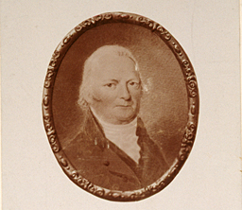
John Bryant served as the Deputy Commissary of Military Stores at the Springfield Armory, managing critical operations related to military supplies. He will provide you with key insights into potential employees for the Amory to hire.

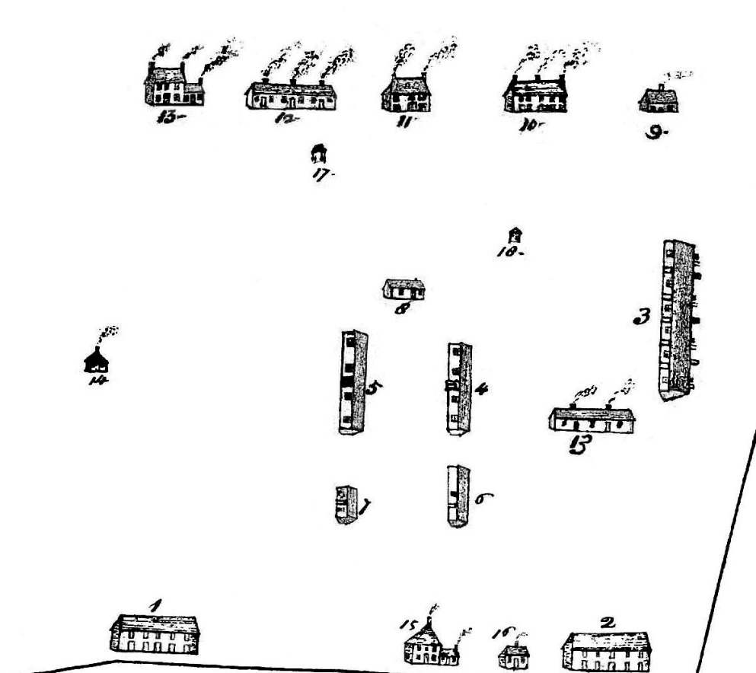
This copy of a map detail is all that is known to survive from an earlier, original map that is now lost. It depicts the buildings and layout of the United States Arsenal in about 1801. It is the earliest known surviving representation of the Arsenal established during the American Revolution at Springfield, Massachusetts, in 1778

Gunsmiths for Hire

Name | Description | Advantages | Disadvantages | Cost
Seth Pomeroy  (150 value) | Highly respected gunsmith from Northampton, Massachusetts, and a veteran soldier of several colonial wars. Pomeroy’s experience as a craftsman and soldier made him a trusted authority on firearm construction, maintenance, and battlefield readiness. | -Expert in firearm design and maintenance.  -Brings battle-tested knowledge, increasing the effectiveness of weapons in combat scenarios. | -Advanced age and military duties may limit hands-on production capacity.  -Focused on combat readiness rather than mass production. | $12,000
David Ames  (50 value) | While his early trade was blacksmithing, Ames oversaw the production of firearms and helped implement standardized parts. Known for combining technical skill with strong organizational abilities, making him a key figure in early American arms production. | -Ensures high-quality weapon assembly and consistent performance.  -Strong managerial skills reduce mistakes. | -May be slower at introducing experimental designs.  -Efficiency depends on well-trained staff. | $7,000
David Mason  (100 value ) | Skilled artisan and officer in the Continental Army during the American Revolutionary War. In January 1777, he was appointed Director of the Board of Works at Springfield, overseeing the establishment of the laboratory and the construction of military stores and fortifications. | -Expert in weapon assembly and maintenance, ensuring high-quality firearms.  -Skilled in logistics and resource management. | -Limited experience in innovative firearm design, focusing more on production and oversight.  May require additional training. | $ 9,000

Blacksmiths for Hire
Name | Description | Advantages | Disadvantages | Cost
Timothy Bigelow  (3 value)  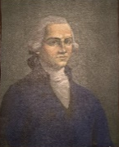 | A blacksmith from Worcester who became a colonel in the Continental Army. After the war, he was placed in charge of the Springfield Arsenal, making him one of the earliest overseers of operations there | -Produces high-quality weapon parts quickly. | -Requires a strong supply chain to reach full potential. | $8,000
Robert Orr  (2 value) | A Massachusetts ironworker, Robert Orr became Master Armorer at Springfield Armory and is credited with pushing greater standardization of muskets around 1804—a key step toward interchangeable parts. | -High-quality, standardized parts; boosts assembly efficiency. | -Higher upfront cost & training; more sensitive to shortages. | $4,000
Richard Falley Jr.  (1 value) | Westfield blacksmith-armorer and Revolutionary War veteran, Richard Falley Jr. produced muskets at his works near Mt. Tekoa and later held leadership at the Springfield Armory (state period He embodies the artisan-to-manager lineage that fed the Armory’s early growth | -Versatile problem-solver; safety bonus | -Slightly higher defect rate without precision oversight; sometimes pulled away for admin duties. | $3,000

Carpenters for Hire
Name | Description | Advantages | Disadvantages | Cost
Major Eayrs  (3 value) | A Boston-born craftsman who served in the Continental Army, known for his ability to organize large teams of carpenters and laborers, he played a key role in getting the Armory’s physical infrastructure operational during its early years. | -A carpenter who “commanded the woodworkers at the arsenal,” and whose orders sometimes extended to metalworkers | -Efficiency drops sharply if lumber supply is interrupted. | $6,000
David Irish  (2 value) | A carpenter who “commanded the woodworkers at the arsenal,” and whose orders sometimes extended to metalworkers | -Real supervisory experience  -Cross-discipline authority lets him coordinate with blacksmiths/gunsmiths for stocks, carriages, crates, and fixtures. | -Split attention: oversight of multiple shops can slow purely carpentry tasks. | $4,000
Ebenezer Stebbins  (1 value) | A Springfield resident who played a pivotal role in the early operations of the Springfield Armory during the Revolutionary War. In 1777, the Continental Army rented a barn from Stebbins, located near the Hitchcock House on Main Street. | -Strong local ties: can source lumber, crews, and workspace quickly. | -Private-property reliance: disruptions (rent, repairs) can bottleneck production. | $2,000

Powdermakers for Hire
Name | Description | Advantages | Disadvantages | Cost
Elias Thornton  (12,000 value) | Skilled laborer recruited from Springfield to work in the early gunpowder production operations at the Armory in 1777. He specialized in grinding, mixing, and testing powder for muskets and small artillery. | -Produces reliable, high-quality gunpowder, reducing weapon failures.  -Can train assistants to maintain production consistency. | -Sensitive to raw material shortages; production slows if sulfur, charcoal, or saltpeter is scarce. | $5,000
Jonathan Carver  (6,000 value) | A millwright from western Massachusetts, was assigned to the Springfield Armory to oversee powder testing and laboratory maintenance. He ensured batches met safety and performance standards before shipment to the Continental Army. | -Improves safety and stability of gunpowder stocks.  -Detects and corrects defective batches, preventing accidents. | -Testing and quality control is time-consuming, slowing total output. | $3,000
Samuel Whitman  (3,000 value) | A chemist and craftsman, worked at Springfield in the Armory’s early experimental laboratory, helping develop more effective powder mixtures and improving storage techniques. His innovations reduced spoilage and increased shelf life. | - Increases production efficiency through improved formulas.  - Reduces wastage and spoilage, maximizing available materials. | -Experimental work carries higher risk; some batches may fail.  -Requires special equipment and controlled conditions to succeed. | $1,000

Budget Entering Round 3: ___________________________________________________________

Remaining Budget: ________________________________________________________________

